1. **Install Power BI Desktop and share the final screenshot of the report view page which appears when power desktop starts.**

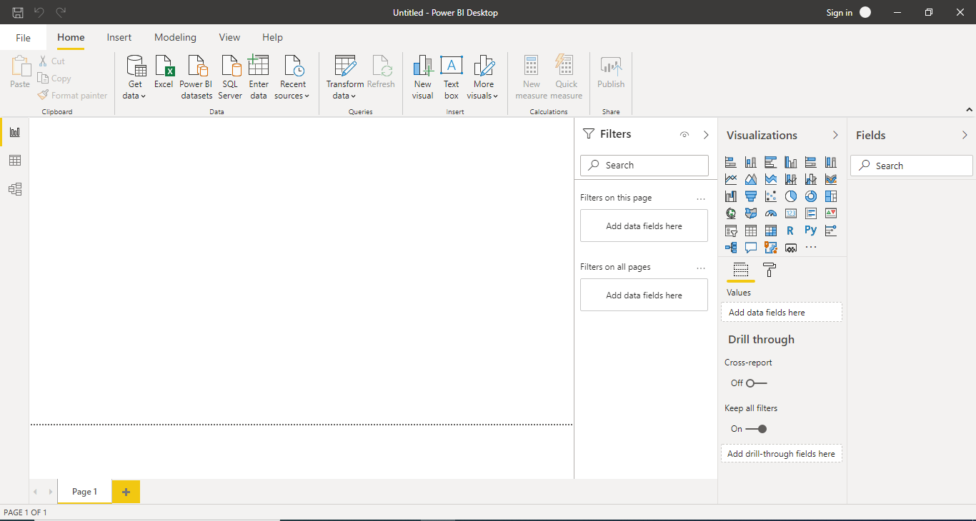

1. **Prepare a document and with the following screenshot**

**− Report View**

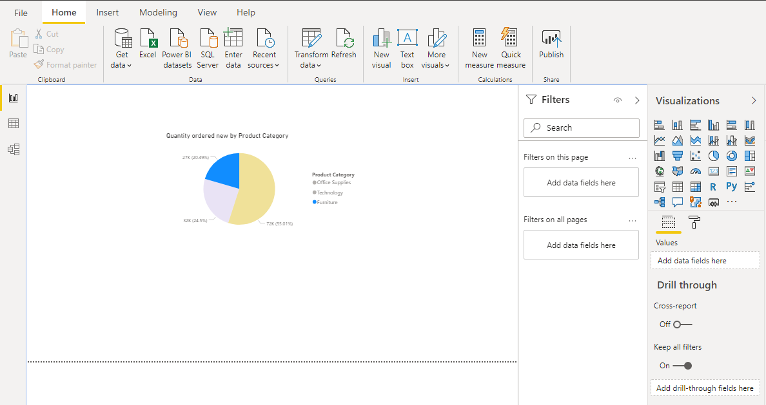

**−Data View**

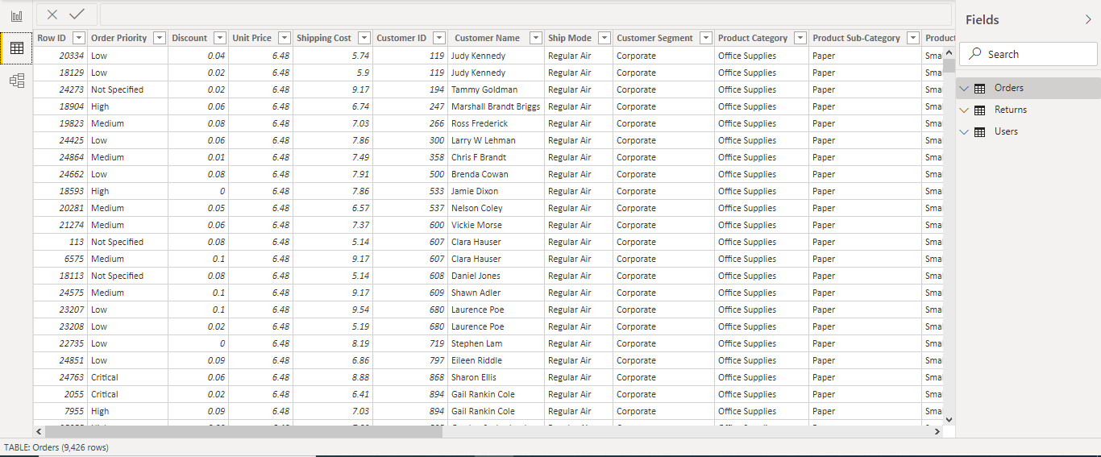

**− Model View**

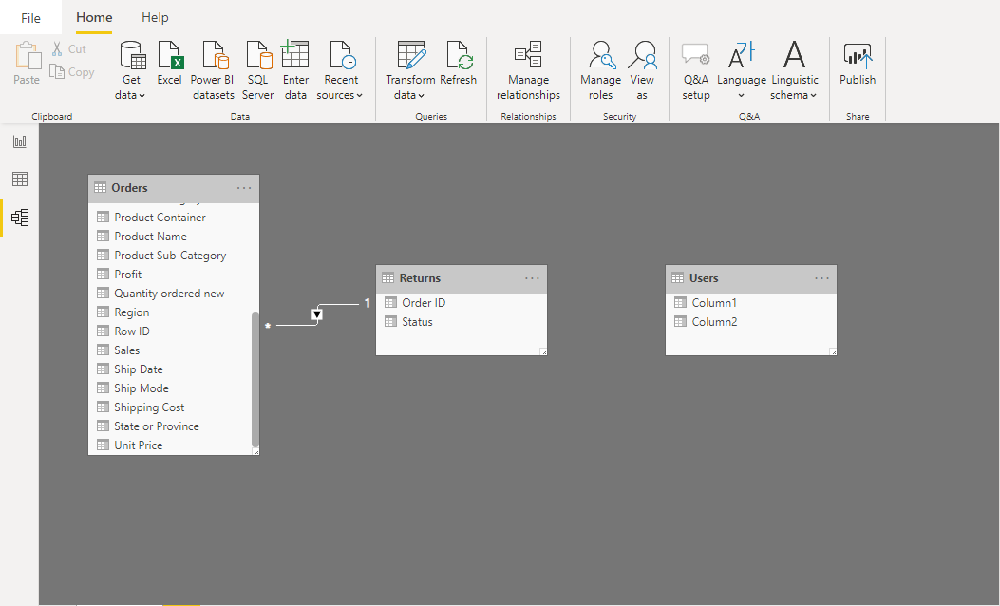

**−Power Query Editor**

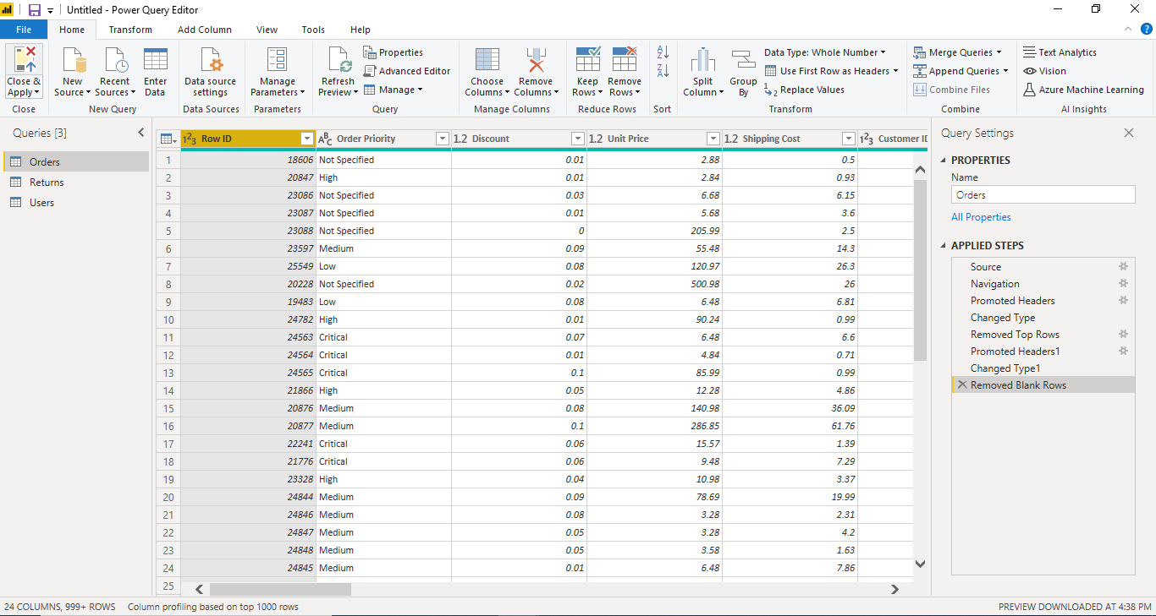

**−Advance Editor**

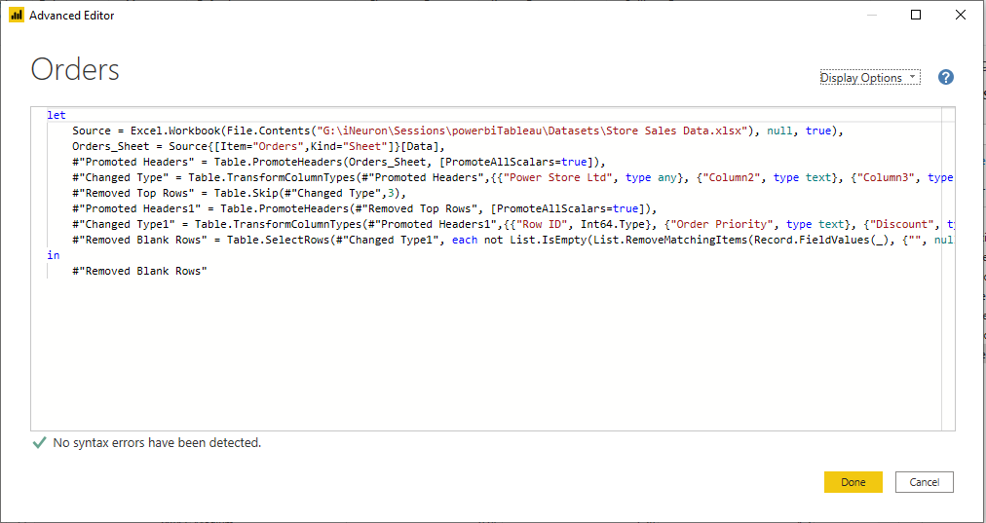

1. **Prepare a document with details of the following along with their price**

**− Power BI Desktop**

Power BI Desktop is a free version which can be installed on local computer to work on reports, prepare models. This is useful to connect data, transform and clean the data and create models. Create Visualizations based on the type of data and create reports with combination of visuals. Power BI Desktop storage limits to 10GB per user. We will not be able to share the reports with Power BI desktop

**Price:** Free

**− Power BI Pro**

Power BI pro is full version including Power BI desktop features. With Power BI Pro will be able to share the reports, datasets and dashboards with other Power BI Pro users. Power BI Pro license is for individual user. This gives the user to create reports and unlimited viewing any created content. Maximum number of refreshes per day is 8.

**Price:** $9.99 per month

**− Power BI Premium**

Power BI Premium is most expensive tier of power bi currently available and very different from Power BI desktop and Power BI Pro. Power BI premium suits for specific size of organization

Maximum storage is 100 TB and maximum number of refreshes per day is 48.License can be purchased for group of people instead of individual user

**Price:** $4995 per month per dedicated cloud compute and storage resource with annual subscription